## Conceptual Schema

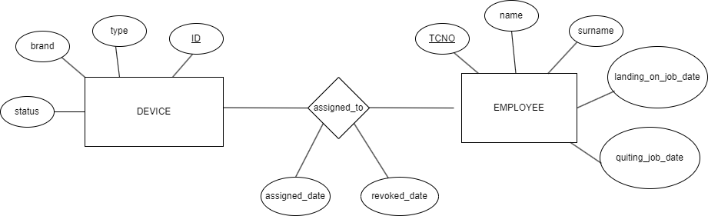

## Logical Schema

DEVICE [ID, type, brand, status]

EMPLOYEE [TCNO, name, surname, landing_on_job_date, quiting_job_date]

ASSIGNED_TO [ETCNO, DID, assigned_date, revoked_date]

*ETCNO is a foreign key refers to EMPLOYEE

*DID is a foreign key refers to DEVICE

## Physical Schema

DEVICE [ID, type, brand, status]

CREATE TABLE DEVICE (

ID VARCHAR (100),

type VARCHAR (100),

brand VARCHAR (100),

status ENUM('working', 'broken', 'under repair', 'idle'),

CONSTRAINT pk_device PRIMARY KEY ( ID ));

EMPLOYEE [TCNO, name, surname, landing_on_job_date, quiting_job_date]

CREATE TABLE EMPLOYEE (

TCNO VARCHAR (10),

name VARCHAR (100),

surname VARCHAR (100),

landing_on_job_date DATE,

quiting_job_date DATE NULL,

CONSTRAINT pk_employee PRIMARY KEY ( TCNO )

CONSTRAINT chk_tcno_numeric CHECK (TCNO REGEXP '^[0-9]+$'));

ASSIGNED_TO [ETCNO, DID, assigned_date, revoked_date]

*ETCNO is a foreign key refers to EMPLOYEE

*DID is a foreign key refers to DEVICE

CREATE TABLE ASSIGNED_TO (

ETCNO VARCHAR (10),

DID VARCHAR (100),

assigned_date DATE,

revoked_date DATE,

CONSTRAINT fk_did FOREIGN KEY ( DID ) REFERENCES DEVICE ( ID )

ON DELETE CASCADE

ON UPDATE CASCADE,

CONSTRAINT fk_etcno FOREIGN KEY ( ETCNO ) REFERENCES EMPLOYEE ( TCNO )

ON DELETE CASCADE

ON UPDATE CASCADE,

CHECK (revoked_date IS NULL OR revoked_date > assigned_date),

CONSTRAINT pk_assigned_to PRIMARY KEY ( ETCNO, DID ));